**FINAL TEST**

**PEMOGRAMAN BERORIENTASI OBJEK**



Fakhita Nur Aziza

51019007

PRODI SISTEM INFORMASI

STMIK KHARISMA MAKASSAR

2022

Screenshoot Tampilan

* Hitung

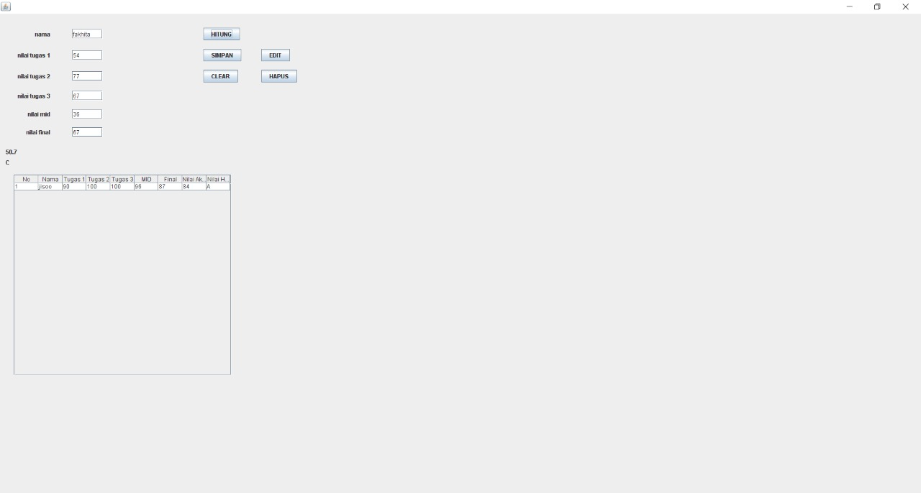

* Simpan

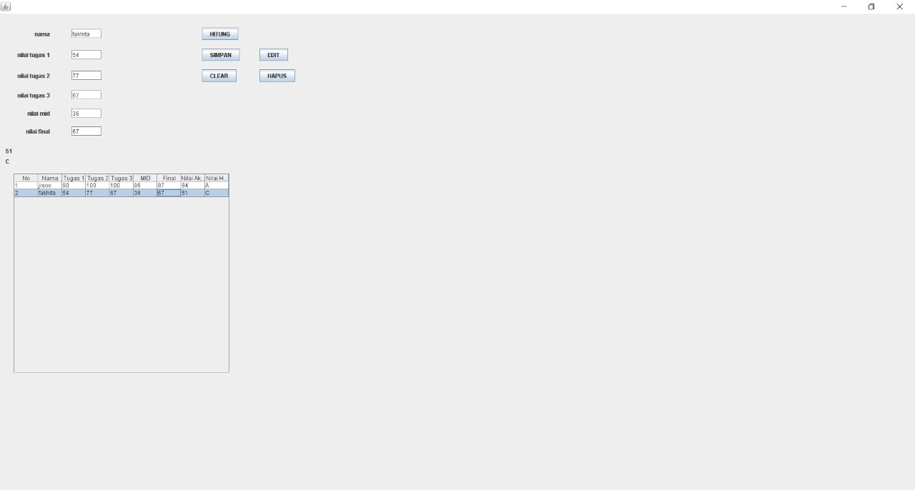

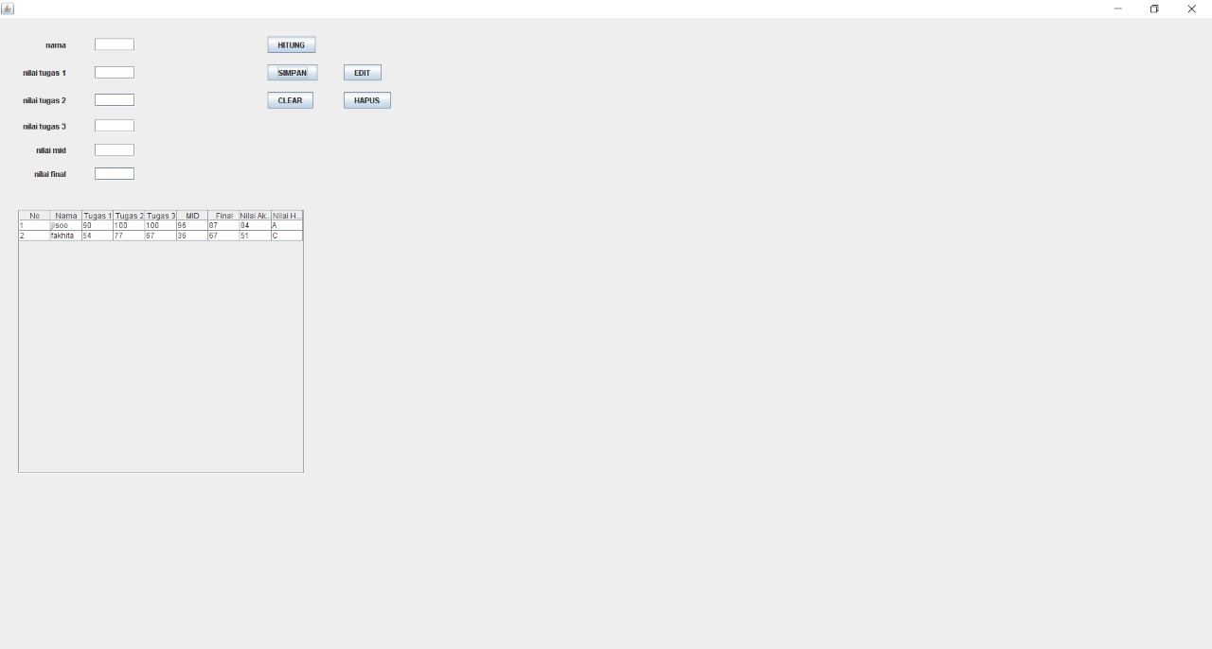

* Clear

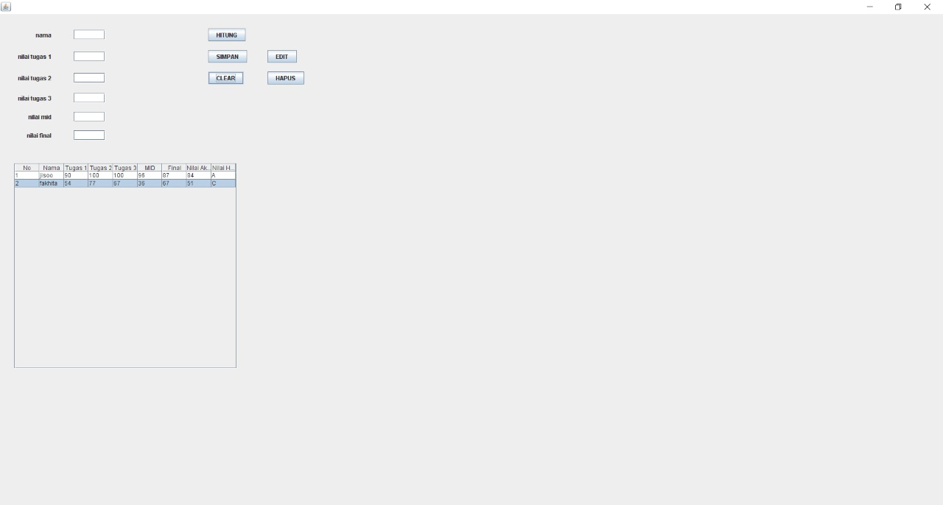

* Hapus

